St. Joseph’s College

Positive Behaviour Policy

A Guide for Students, Staff and Parents

February 2016

Positive Behaviour for Learning at St Joseph’s College
A Guide for Students, Staff and Parents

Introduction
The mission of St Joseph’s College is to be a Catholic College where every individual is highly valued and where care and concern for others is central to our work. We aim to create a happy and supportive environment for all. Every aspect of the College reflects our very special Catholic ethos and Lasallian way of life. Our badge contains the Latin phrase “Fides Intrepida” – Fearless Faith – an appropriate motto for today’s students as they embark on their own individual journey through life.
All our students are expected to achieve their full potential and become equipped for adult life. We want all our students to leave the College ready to take their place in modern society, with each individual reaching his or her potential, both academically and socially. Central to this expectation is our belief that to achieve this all students have the right to be educated in an environment where there is mutual respect and co-operation, guided by the gospel values.
Every student and every member of staff should feel confident that their working environment is one where people are kind, courteous and respectful at all times. All staff, both teaching and support staff, have the right to work in an environment where they can use their knowledge, skills and abilities for the benefit of all students. This policy aims to promote positive behaviour for learning from students.

At school, in every situation where there are rules, students either choose to follow them or they make a choice to break them and face the consequences. The rules have to be clear and the consequences need to be consistent for this to work and that is our aim in implementing our behaviour system. The consequence of a lack of consistency and lack of mutual support will be misbehaviour.

When dealing with misbehaviour, staff should act with authority without being authoritarian; staff should be assertive without being aggressive. Unless we can use our emotional intelligence to demonstrate these differences our young people will not develop the emotional intelligence to recognise the difference either.

All members of the College community will foster an atmosphere where positive behaviour is emphasised and encouraged; the College will be a place where praise is at the centre of our culture and is used to ensure progress.

Mr D Garrido: Headmaster
Mr G Mantillas: Assistant Headteacher, Behaviour

This document includes 2 key policy areas to ensure students can maximise their potential in an environment of mutual respect and co-operations. This includes:
1) Positive Behaviour Policy
2) Consequences following poor behaviour
Positive Behaviour Policy
1.1 Principles of Positive Behaviour Management
The basis of excellent behaviour management is to have care and concern for others at the centre of what and why we do it.
For students to achieve their full potential and is the need for excellent Learning and Teaching to take place in lessons.
Excellent behaviour by students and exceptional behavioural management is the cornerstone to excellent teaching and learning.
At the core of positive behaviour is effective, imaginative and engaging teaching.
The staff in the college should always look to operate as a team, with a strong team ethic in teaching/learning and behaviour management. You need to work clearly with and in communication with the pastoral teams utilising their perspective and expertise and make effective use of parents.
Good behaviour management will be progressive, consistent and fair in its use of rewards and sanctions. We can mould or shape behaviour but not control it!
To be effective in your behaviour management of students you must ensure that you know and have discussed the department and college expectations of behaviour. You must communicate these to students and consistently work towards these patiently.
Behaviour management is central to a student’s development – it develops the individual and how they relate to others in the world around them. It is not simply about getting them to let you do your job. Behaving appropriately is part of their learning.
As the teacher, always remain the calmest, coolest head in the room.
Avoid confrontation where possible and be careful about the where and when you chose to take issue with students.

1.2 The SJC Teacher Approach
It is important that we have a model as to the type of teacher we aspire to be in our management of behaviour in the classroom. Broadly speaking there are three types of teachers; aggressive, passive and assertive. Their characteristics are outlined below:
Aggressive | Passive | Assertive
Threatening | Pleading | Firmly states
Shouting | Whining voice | Calm voice
Over-reacting | Only responds to extremes | Wide range of responses
Unpredictable | Becomes embroiled in debate | Consistent
Cynical | Apologetic | Praises
Overbearing | Over-reliance on others | Gives students take up time
Humiliates students | Doesn’t circulate | Highlights positive behaviour
Generic sanctions | Threatens but fails to implement | Gives choices
Targets the person | Ignores situations | Targets behaviour
At SJC we aspire to be the assertive teacher. This is the approach that SJC students respond to and the one in which learning will be most effectively enhanced.

1.3 The SJC Code of Conduct
The following is the outline of the expectations we have for students:
We will all do our best to behave in a way that shows Respect for Learning.
This means:
•Attending each day and arriving on time for college and lessons
•Bring everything we need to lessons
•Listening to instructions and following them
•Doing our best and taking pride in all class and homework
•Making it easy for everyone to learn and for the teachers to teach
We will all do our best to behave in a way that shows Respect for Self.
This means:
•Being honest with ourselves and to others
•Making good use of our time
•Taking good care of ourselves and our property
We will all do our best to behave in a way that shows Respect for Others.
This means:
•Being courteous, co-operative and friendly
•Showing consideration for other people’s feelings and points of view
•Making it easy for other people to achieve and being pleased when they do
•Taking care of other people’s property
•Moving around the college safely and sensibly
We will all behave in a way that shows Respect for the College.
This means:
•Wearing the correct clothes for college
•Taking good care of property and the environment, in and around the college
•Making sure we always give the impression of the college
•Playing an active part in helping improve the college and the local community

1.4 Procedures
At SJC we trust and empower our staff by considering the behaviour standards in the classroom to be the responsibility of the classroom teacher. Support is always at hand, however, so please do not be reticent in asking for it. We deal with issues as a team at SJC. It is not a sign of weakness to have difficulties, but it is to ignore them.
If you encounter behaviour situations within your lessons that you would like support with or that you feel requires further intervention there are the following people available to help:
•Head of Department: They should always be your first port of call for any issue within your classroom that you would like support on
•Head of Year: You should refer issues in your classroom onto the head of year once you have first discussed them with your head of department.
•Learning Support Department: It may be that the root cause of behaviour problems with students in lesson may be down to their frustrations and difficulties in learning. This is often particularly acute with students with learning difficulties. We have a superb learning support department with a wealth of experience and understanding. They are very willing and able to help. Please make use of them.
•Deacon Tony Flavin has experience of dealing with students in all sort of situations and backgrounds. He is very skilled at supporting staff and students
•SLT: The SLT mainly get involved in behaviour matters when they are called to pick up a student who is being removed to the Exit Room. Please ensure that they are given as much detail as possible so that this can be relayed to the Exit Room Manager. The Exit Room Manager will contact parents to inform them of the setting of ‘Protecting Learning’ detention.
If you encounter behaviour situations outside of lessons that you consider require further intervention then you should use the Basic9 procedure.

2 The Consequences
Students’ behaviour around the school should be impeccable; every lesson should be characterised by a relentless focus on learning, free from distractions. If student behaviour falls short of our expectations there are a set of consistent consequences that follow:
To make the system easy for everyone to understand, our new behaviour policy is divided into 2 main sections.

- A set of consequences for disruption of learning within the classroom – Know as (C1, C2 and C3).
- A set of expectations around our 9 basic behaviour expectations. These are known as B9 or Basic 9.

Sanctions for students who do not keep to our expectations are described below:

For not following our Basic 9 (B9) expectations:

B9: A 30 minute same day detention is issued as an immediate consequence if a student fails to follow the Basic 9 behaviour expectations of the college. This detention will be issued for the same day. B9s will be logged by the member of staff concerned or a slip brought down to the front office to be logged.

For disrupting learning within the classroom:

C1: A first warning, firmly given. This is a signal that a student’s behaviour is unacceptable and is affecting learning and therefore needs to be changed. For a C1, a student’s name will be listed on the whiteboard but if no further problems arise, no further action is taken.

C2: The second warning. This indicates that the student is on the edge of a significant
consequence and is continuing to affect the learning taking place in the classroom and must comply with the rules without fail. Again, the student’s name is listed.

The C1 and C2 consequences are only used in classrooms and allow teaching staff to refocus students on learning as firmly and as quickly as possible. No further action is taken provided that they return to behaviour that is consistently within the rules. At this stage teachers will reiterate the consequence of receiving a C3.

C3: The student will be exited from the class for the period and this will be logged by staff
in the Exit Room.

A same day “Protecting Learning Detention” for up to 90 minutes after college will be set.
All detentions will take place the same day in the designated area or the main hall from 2.35-4.05pm, Monday to Friday.

All C3s should be completed without negotiation. It is the responsibility of the individual student to attend and to use the time productively. Students can continue the work from the lesson they missed, complete assignments, engage in productive study or, if they have no other work to do, they can read.

Students who engage with the C3 detention sensibly and seriously will be dismissed after 60 minutes. Those who do not engage and do not take the initiative to engage in study or reading will stay for 90 minutes. C3s will be supervised by the Senior Leadership Team and Middle Leaders.
Current legislation does not require us to give parents notice of after-school detentions or tell them why a detention has been given, but as a college, and as a matter of courtesy, we aim to notify all parents to inform them that a C3 detention has been issued. This will be happen as soon as we can to give as much notice as possible.

We will take action if students contact their parents during the school day in order to protest about their C3.This will undermine the system. If a C3 is missed, a parental meeting will be called for the following day and the full 90 minute detention reset for that afternoon.

Please inform the college immediately if contact details have changed. A C3 detention takes priority over any other activity within school and the school will consider it an extension to the school day and compulsory to attend. If a student has a medical appointment, parents should call main reception to leave a message so that the C3 can be reset for the following day.

If students receive multiple C3 detentions they must all be served on consecutive days until all detentions have been completed. If a student has more than three in a half term, they will be placed in the pupil internal exclusion room (PIER) for a day.

Any student who truants a lesson will be issued a C3 Protecting Learning detention for the subject that was missed.

Serious Offences – superseding Basic 9 or Protecting Learning sanctions

L4: A full day in our pupil internal exclusion room (PIER) under strict supervision.
Students who repeatedly fail to follow the Behaviour for Learning Policy or the sanctions issued, will be required to sit in isolation, to work in silence and to complete the work that is set. This is a very serious sanction. It signifies that the student has made choices that are unacceptable within our community. The isolation day gives them a chance to reflect on the choices they have made. This sanction will also involve a parental meeting with a member of the Senior Leadership Team and the Head of Year. Students who misbehave during their time in the Isolation room will receive a fixed term exclusion.

Every effort will be made to contact parents to explain why this sanction has been issued, but until the meeting has taken place the student will be held in isolation. Whilst inconvenient there is an expectation that parents make themselves available to attend this meeting if necessary.

Explaining how the system works

In the Classroom - Students are expected to follow these simple rules in every lesson:
- Respond promptly to the signal for attention
- Follow instructions from staff when given
- Remain on task as directed
- Listen when others are speaking

Teaching staff will use the C1, C2 and C3 sanctions if students do not follow these rules.
Teaching staff will explain their signal for attention to their students and will make it clear what each task is as the lessons progress.

Exit from the classroom

Students who disrupt learning persistently or significantly will be issued a C3 and will be removed from the classroom. The Senior Leadership Team will be called and the student will be sent to the Exit room. If appropriate, they will return to lessons the following period, and will be spoken to by the issuing member of staff in their 90 minute detention. Any student who is sent to the Exit room twice in one day, will not return to lessons that day and this will trigger a parental meeting.

B9 (Basic 9 Expectations)

If students break the following rules, they will be given an automatic B9 same day Detention.

1. Late to school/lessons
This means students are expected to be on time for morning registration (8.15), assembly and lessons after break or after lunch. Students will be issued an immediate B9 if they are late. Late also means no later than 5 minutes after the bell at lesson change-overs.

2. Be equipped:
This includes a pen, a pencil, a ruler, the books for the lesson and planner. It also includes musical instruments, PE kit and a calculator for maths.

3. No use of electronic devices in school
Mobile phones need to be switched off and out of site at all times. The consequence for using phones and other devices (earphones) without permission is a B9 and confiscation of the item. We will only return the items to parents. If students choose to break this rule, they have made a choice to cause their parents the inconvenience of attending school to collect the item. Refusal to cooperate with a confiscation will result in a parental meeting, Isolation or a possible exclusion.

4. Uniform:
Students are expected to wear the correct uniform at all times. If a student is not in correct uniform they will be sent home and should return once they are presented according to our expectations.

5. Out of Class:
Any inappropriate conduct outside of the classroom, such as play fighting, swearing or shouting in the corridors and loitering at Crown Point after 3pm, will result in a B9 detention.
*No toilet breaks are allowed during lessons unless a student has been issued with a note from the doctor that there is a medical condition.

6. No Homework
Any student who fails to hand in homework by the teacher’s specified time, will be issued with an immediate B9 detention.

7. Littering
The School site has waste bins in every classroom and at various key external areas. Any student seen dropping litter will be issued with an immediate B9 detention.

8. Eating/Chewing/Drinking
No eating or drinking should take place in any area of the school other than the dining room or outside in the designated areas of the playground (cold food only). There should be no food or drink consumed in the school building. Only water is allowed within lessons. Chewing is completely banned anywhere in the school building or in the outside areas.

9. Respect
Students are expected to treat everyone and the school environment with respect.

Serious incidents or failure to cooperate will be dealt with via a L4 Isolation or Exclusions.

Multiple B9s (4 or more) within a week will result in a 90 minute detention.

Serious Offences:

There are a number of behaviours that are non-negotiable and will be dealt with by issuing either a L4 Internal Exclusion or a Fixed Term Exclusion. Both Offences will also involve a parental meeting.
These are not limited to, but include:

- Blatant defiance, including walking away when being spoken to by any member of staff
- Violence of any kind
- Abusive language to any staff member
- Racist, sexist or homophobic language
- Harassment or bullying.
- Anti-social behaviour: spitting, graffiti, vandalism
- Damage to property or theft
- Any act in public that brings the school into disrepute, any crime relating to violence, drugs or carrying weapons, is likely to result in permanent exclusion.

The Behaviour Support Centre:

In situations where students are repeatedly given C3’s, spending multiple days in isolation or receiving fixed term exclusions, we will consider placing them in our Behaviour Support
Centre.

This is a ‘buffer zone’ between the mainstream school community and a permanent exclusion. Each individual will be assessed and staff will deliver a personalised programme that enables the students to develop the attitudes and skills needed to comply with our expectations.

Students will be expected to demonstrate that they are ready to return to mainstream lessons, ready to respect the privilege of wearing the St Joseph’s College uniform and ready to engage in learning without disrupting the learning of others.

The message to students in the Behaviour Support Centre is clear: they are only there because of the poor choices they have made and we will not tolerate behaviour that disrupts the learning of other students or spoils the caring environment we have created.

Rewards

We operate a rewards system through awarding achievement points and positive acknowledgements in various forms. We celebrate achievement in all its forms – including academic success, sporting success and engagement with music. We will acknowledge and celebrate all students who receive excellent behaviour grades throughout the year and who have the lowest behaviour points.

The Behaviour for Learning Flow Chart
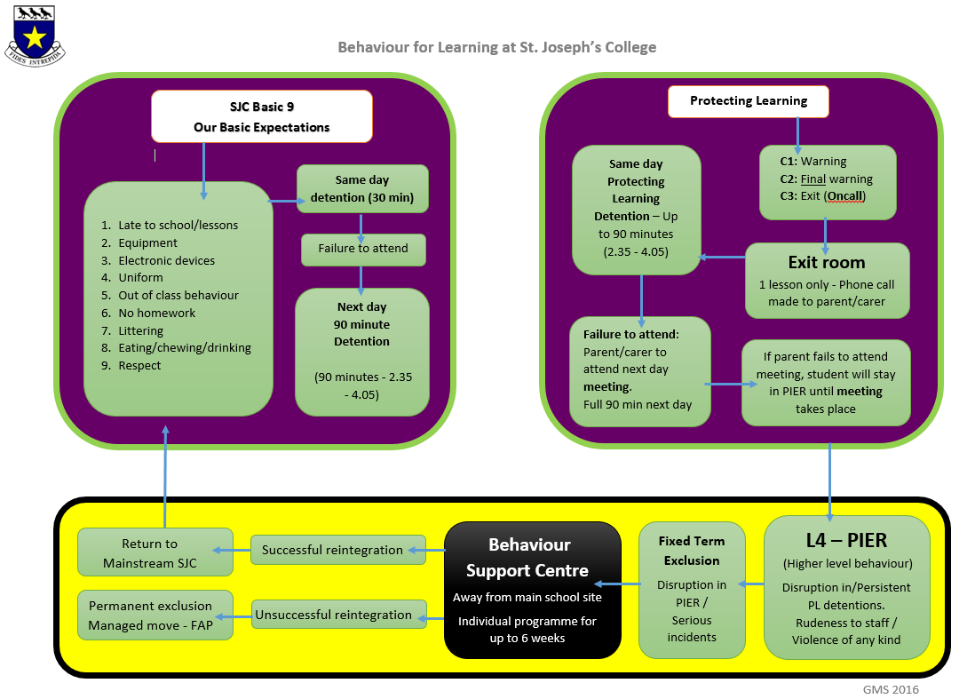
“Fides Intrepida”
Date:
To be reviewed at Governing Body’s discretion

