Year 11 Pre-Public Examinations
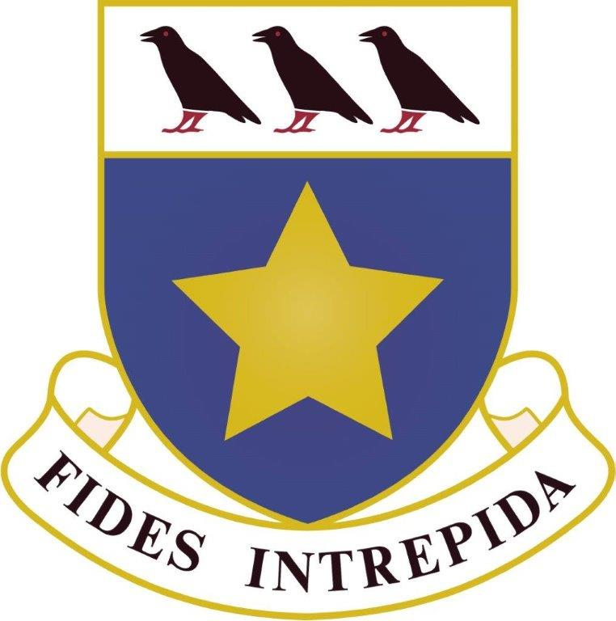
(9 – 22 December 2016)

Exam Date | Exam Time | Subject | Exam Venue
Friday 9 December 2016 | All Day | Art / Photography | Art Block (H02 / H12)
All students in school | 10:20 – 11:50 | Catering | Hall
 | 10:20 – 12:20 | Graphics | Hall
 | 10:20 – 12:20 | Resistant Materials | Hall
Monday 12 December 2016 | All Day | Art / Photography | Art Block (H02 / H12)
All students in school | 10:20 – 11:10 | Mandarin YCT (Year 10) | Hall
 | 11:20 – 11:55 | Mandarin YCT (Year 9) | Hall
Tuesday 13 December 2016 | 08:20 – 09:50 | Maths | Hall / Gym
 | 10:25 – 12:25 | English | Hall / Gym
 | 13:20 – 15:20 | Graphics / Catering / DT  Clashes | Gym
 | 13.20 – 14:55 | Mandarin YCT Year 11 | Hall
Wednesday 14 December 2016 | 08:20 - 09:50 | Religious Studies | Hall & Gym
 | 10:25 - 12:25 | Chemistry  C1 (Sets 1-8)  C2 (Set 1) | Hall & Gym
 | 13:20-14.50 | Music | V01
Thursday 15 December 2016 | ALL DAY | Science | All day in Science
All students in school
Friday 16 December 2016 | 08:20 - 09:50 | Maths | Hall & Gym
 | 10:25 - 12:25 | Biology  B1 (Sets 1-8)  B2 (Set 1) | Hall & Gym
 | 13.20-14.50 | PE | Hall
Monday 19 December 2016 | 08:20 - 09:50 | Maths | Hall & Gym
 | 10:25 - 12:25 | Physics  P1 (Sets 1-8)  P2 (Set 1)  Additional Science Paper  Part B2,C2,P2 (Set 2-8) | Hall & Gym
 | 13.20-15.05 | Business Studies | Hall
Tuesday 20 December 2016 | 08:20 - 09:50 | Religious Studies | Hall & Gym
 | 10:25 - 12:25 | History | Hall
 | 13.20-14.50 | Computing | Hall
Wednesday 21 December 2016 | 08:20 - 08:50 | French F Listening | Gym
 | 08:20 - 08:50 | Spanish F Listening | Hall
 | 09:00 - 09:50 | French Reading | V01
 | 09:00 - 09:50 | Spanish Reading | Hall
 | 09:00 - 09:50 | Mandarin Reading | V01
 | 10:10 - 10:50 | French H Listening | Gym
 | 10:10 - 10:50 | Spanish H Listening | Hall
 | 10:10 - 10:50 | Mandarin H Listening | V01
Thursday 22 December 2016 | 08:15 – 12:40 | Catering / Resistant Materials / Geography | TBC

